Kubernetes task 07

Task 1: Execute all yaml files shown in video.

Task 2: Taint a Node and Schedule a Tolerant Pod Taint a node with special=true:NoSchedule. Create a pod with a toleration that matches the taint, allowing it to be scheduled on the tainted node.
  - # kubectl taint nodes worker-1 special=true:NoSchedule
  - # kubectl describe node worker-1 | grep -i taint
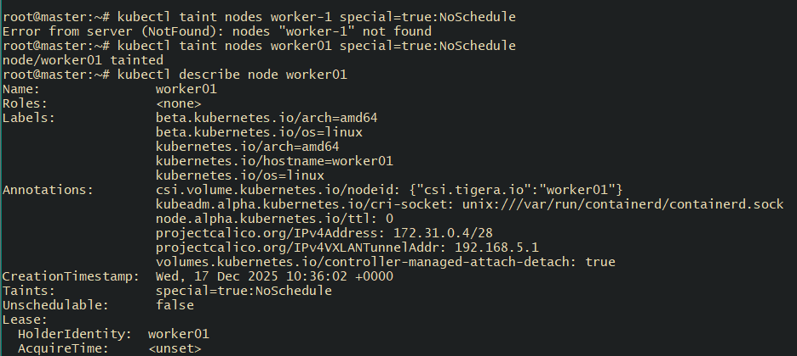
# vi tolerationpod.yml -- >write the yml file to create the pod with matching toleration
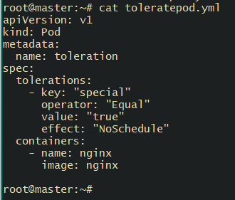
apiVersion: v1
kind: Pod
metadata:
name: toleration
spec:
tolerations:
- key: "special"
operator: "Equal"
value: "true"
effect: "NoSchedule"
containers:
- name: nginx
image: nginx

  - # kubectl apply -f toleration-pod.yaml
# kubectl get pod -o wide – check the pod scheduling
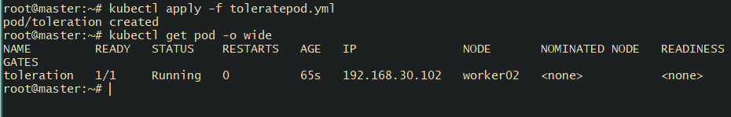

Task 3: Use NodeSelector to Schedule a Pod on a Specific Node Label a node with env=dev. Create a pod with a nodeSelector that schedules it only on the node labeled env=dev.
Label the node with env=dev
# kubectl label node worker01 env=dev
Check the label on node
# kubectl get nodes --show-labels
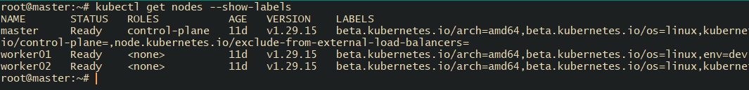
Create a Pod with nodeSelector
# vi nodepod.yml
apiVersion: v1
kind: Pod
metadata:
name: nodeselector-pod
spec:
nodeSelector:
env: dev
containers:
- name: nginx
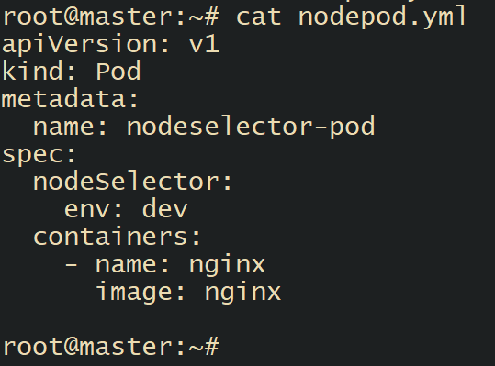
image: nginx
#kubectl taint nodes worker01 special:NoSchedule- : untaint the node because we have labeled the node a dits taint for noschedule the pod will be be in pending state
# kubectl apply -f nodepod.yml : create the pod
You can see the pod is running on the node that is labeled with env=dev
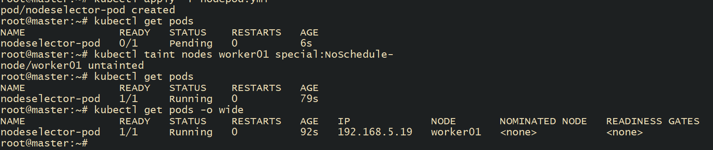

Task 4: Use Node Affinity with Soft Scheduling Label a node with env=test. Create a pod with PreferredDuringSchedulingIgnoredDuringExecution node affinity, preferring to schedule it on a node labeled env=test. Remove the label and verify the pod continues to run.
Label the node with env=test
# kubectl label worker02 env=test
# kubectl get nodes --show-labels
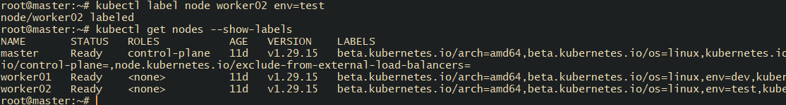
Write an yml file to create pod with node selector
# vi nodepod.yml
apiVersion: v1
kind: Pod
metadata:
name: soft-affinity-pod
spec:
affinity:
nodeAffinity:
preferredDuringSchedulingIgnoredDuringExecution:
- weight: 100
preference:
matchExpressions:
- key: env
operator: In
values:
- test
containers:
- name: nginx
image: nginx
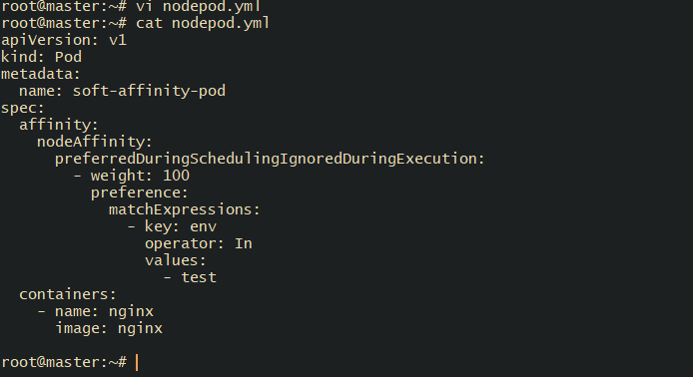
# kubectl apply -f nnodepod.yml
# kubectl get pod -o wide
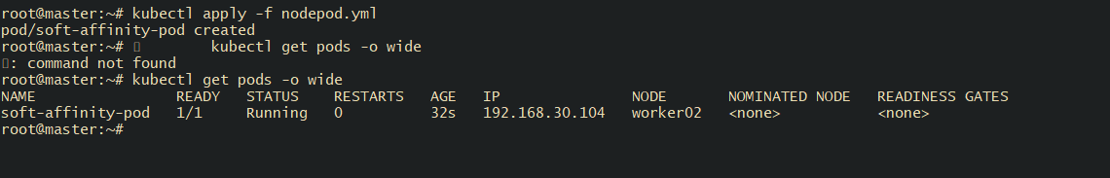

Task 5: Implement Node Affinity with Hard Scheduling Create a pod with RequiredDuringSchedulingIgnoredDuringExecution node affinity, ensuring it will only be scheduled on a node labeled env=prod. Verify the pod cannot be scheduled if no node has the env=prod label.
Verify the nodes does not have the label env=prod
# kubectl get nodes --show-labels
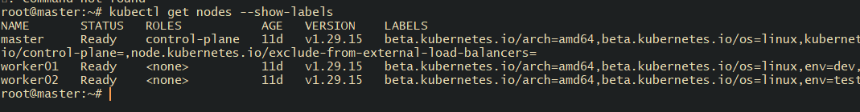
Write a yaml file create a pod with RequiredDuringSchedulingIgnoredDuringExecution
# Vi hardnode.yml
apiVersion: v1
kind: Pod
metadata:
name: hard-affinity-pod
spec:
affinity:
nodeAffinity:
requiredDuringSchedulingIgnoredDuringExecution:
nodeSelectorTerms:
- matchExpressions:
- key: env
operator: In
values:
- prod
containers:
- name: nginx
image: nginx
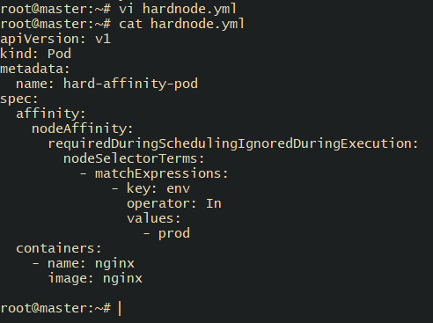

# kubectl apply -f hardnode.yml
# kubectl describe pod hard-affnity-pod

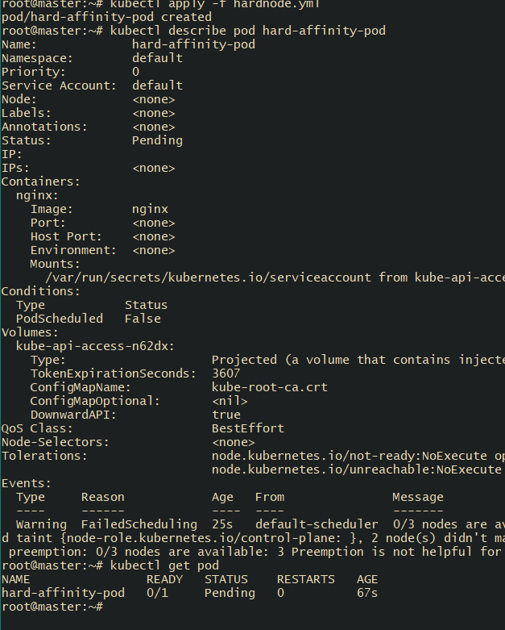

Task 6: Taint a Node and Use NoExecute with Toleration Seconds Taint a node with special=true:NoExecute. Create a pod with a tolerationSeconds field (e.g., 60 seconds) and observe it gets evicted after 60 seconds on the tainted node.
# kubectl taint node worker01 special=true:NoExecute
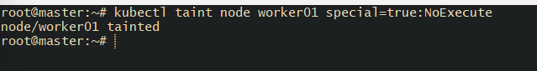
Write a yml file for pod with the toleration = 60 second
# vi tolerate.yml
apiVersion: v1
kind: Pod
metadata:
name: noexecute-pod
spec:
tolerations:
- key: "special"
operator: "Equal"
value: "true"
effect: "NoExecute"
tolerationSeconds: 60
containers:
- name: nginx
image: nginx
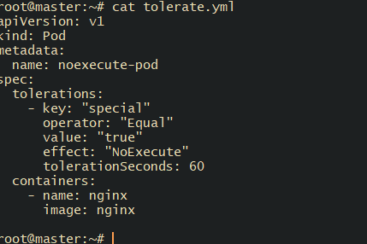

# kubectl apply -f tolerate.yml

# kubectl get pods -o wide
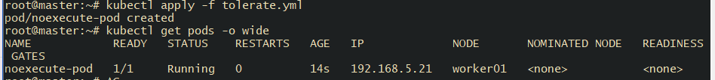

# kubectl get pods -w
You can see after 60 seconds pods get terminated
